RESOLUTION NO.__________

RE: CERTIFICATE OF APPROPRIATENESS UNDER THE
PROVISIONS OF THE ACT OF THE PENNSYLVANIA
LEGISLATURE 1961, JUNE 13, P.L. 282 (53
SECTION 8004) AND BETHLEHEM ORDINANCE NO.
3952 AS AMENDED.

WHEREAS, it is proposed to secure a COA for removal of the existing slate roof sheathing and replacing with architectural shingles at 702 East Fourth Street.

NOW, THEREFORE, BE IT RESOLVED by the Council of the City of Bethlehem that a Certificate of Appropriateness is hereby granted for the proposal.

Sponsored by: (s)

(s)

ADOPTED BY COUNCIL THIS DAY OF

(s)
President of Council

ATTEST:

(s)
City Clerk

HISTORIC CONSERVATION COMMISSION

CASE #650 -- It is proposed remove the existing slate roof sheathing and replace with architectural shingles at 702 East Fourth Street.
OWNER/APPLICANT: John Gross/Francisco J. Lopez

The Commission upon motion by Mr. Evans and seconded by Ms. Starbuck adopted the proposal that City Council issue a Certificate of Appropriateness for the proposed work as presented and described herein:

- The proposal to remove the existing slate roof sheathing and replace with architectural shingles in medium brown color was presented by Francisco Lopez; note: upon inquiry, Mr. Lopez confirmed the proposed work was already completed without HCC review and approval.
- To mitigate the visual impact of incorrect roofing shingles installed without work permits, the lower (more vertical) surface area of the gambrel roof will be re-sheathed in GAF Slateline asphalt roofing shingles in Antique Slate gray color, in consult with the manufacturer concerning proper installation over existing asphalt shingles as well as appropriate flashing details.
- The motion for the proposed work was unanimously approved.

JBL: jbl
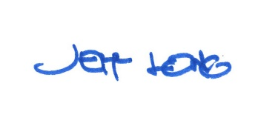

By:

Date of Meeting: June 18, 2018 Title: Historic Officer

